<Rent a Car>

Requirements Specification and Analysis

<1.0>

<16.03.2025>

<Nehir Karameşe>

<Ayşe Korkut>

<Sıla Özcan>

<Ata Kılıç>

<Tuğçe Yeşilyurt>

<Hümeyra Bilgin>

<Eylül Buket Soğukbulak>

<Umut Enis Gögçe>

<Arda Aydoğdu>

<Arda Gül>

<Kaan Berk Kıral>

Prepared for

SOFT3102 Software Engineering Practice



Table of Contents

1. Introduction 1

1.1. Purpose of the System 1

1.2. Scope of the System 1

1.3. Objectives and Success Criteria of the Project 1

1.4. Definitions, Acronyms, and Abbreviations 1

1.5. Overview 1

2. Current System 1

3. Proposed System 1

3.1. Overview 1

3.2. Functional Requirements 2

3.3. Nonfunctional Requirements 2

Usability 2

Reliability 2

Performance 2

Supportability 2

Implementation 2

Interface 2

Packaging 2

Legal 2

3.4. System Models 2

Scenarios 2

Use case model 2

Dynamic model 2

User interface—navigational paths and screen mock-ups 3

3.5. Project Schedule 3

4. Glossary 3

5. References 3

REQUIREMENTS ANALYSIS DOCUMENT[1]

# Introduction

The purpose of this section is to provide a brief overview of the function of the system and the reasons for its development, its scope, and references to the development context (e.g., reference to the problem statement written by the client, references to existing systems, feasibility studies). The introduction also includes the objectives and success criteria of the project.

## Purpose of the System

A reliable, user-friendly, and efficient car rental platform that simplifies vehicle rentals for customers and enhances operational efficiency for companies through digitalization.

## Scope of the System

Sprint 1 User Story Titles:

- Login | User Login

- Login | Logout

- Login | Change Password

- Login | User Profile Page

- Login | Reset Password

-Login | User Register

## Objectives and Success Criteria of the Project

Our goal is to make the car rental process easy for both customers and administrators. We will create an admin panel where managers can control cars and reservations. The system will offer many vehicle options and allow customers to choose flexible rental plans. By digitizing the rental process, we will improve efficiency and reduce manual work. Users will be able to see and list available cars quickly, making rentals faster and more useful.

## Definitions, Acronyms, and Abbreviations

CRUD: Create, Read, Update, Delete

API: Application Programming Interface

DB: Database

UI: User Interface

## Overview

This document follows an incremental versioning approach, meaning it will be updated at the end of each sprint to reflect new developments. The structure is designed to ensure that all project requirements, user stories, and system updates are documented consistently.

* Sections 1.1 and 1.3 (Product Vision & Product Goals) are defined at the start and will remain unchanged.
* Sections 1.2, 3.2, 3.3, 3.4, and 3.5 will be updated at the end of each sprint with new user stories, non-functional requirements, system flows, and sprint dates.
* Section 2 is left empty.
* Section 3.1 will have a new sprint goal added for each sprint.

Each version of the document builds on the previous one, ensuring a structured and well-documented development process.

# Current System

If the new system will replace an existing system, this section describes the functionality and the problems of the current system. Otherwise, this section describes how the tasks supported by the new system are accomplished now.

# Proposed System

Documents the requirements elicitation and the analysis model of the new system.

## Overview

In first sprint, our main goal is to develop and enhance the user authentication system for the Rent a Car platform. We will implement the admin login, allowing system administrators to securely access the platform and manage cars and reservations. Additionally, we will enable customer login, so users can sign in to view available vehicles and manage their rentals. To ensure security, we will implement a logout feature, allowing users to safely exit their accounts. Another key objective is to introduce the forgot password functionality, enabling users to reset their passwords via email. Lastly, we will create a user profile page, where users can view their account details and update their passwords if needed.

## Functional Requirements

1. **User Authentication Login | User Login**

As a user, I want to log into the system so that I can make car reservations and manage my existing rentals.

**Acceptance Criteria:**

* The customer will enter their username.
* The customer will enter their password.
* The customer will click Login button.
* If login is successful, the customer will be redirected to the homepage.
* If login is unsuccessful, the customer will receive an error message.

1. **User Authentication Login | Logout**

"As a user, I want to log out of the system securely so that my account remains protected. Acceptance Criteria:

* The user will click the "Logout" button.
* The user will be redirected to the login page.

1. **User Authentication Login | Change Password**

As a user, I want to reset my password if I forget it so that I can regain access to the system. **Acceptance Criteria:**

* The user will click the "Forgot Password" link/button.
* The user will be redirected to the "Forgot Password" page.
* The user will enter their email and click the "Submit" button.
* The user will receive an email with a password reset link.
* The user will enter the new password twice.
* If the password change is successful, the user will be redirected to the login page and will be required to log in with the new password.
* If the passwords do not match, the user will receive an error message.

1. **User Authentication Login | User Profile Page**

As a user, I want to access my profile page so that I can view my personal details and change my password.

**Acceptance Criteria:**

* The user will click on the profile icon in the top right corner of the homepage.
* The user will be redirected to the "User Profile" page.
* The system will display user information and a "Reset My Password" link.

1. **User Authentication Login | Reset Password**

As a user, I want to be able to change my password from the profile page after logging in so that I can enhance my account security.

**Acceptance Criteria:**

* The user will click the "Reset My Password" button to set a new password.
* The user will enter the new password twice.
* If the password change is successful, the user will be redirected to the "User Profile" page.
* If the passwords do not match, the user will receive an error message.

1. **User Authentication | User Register**

The user should be able to register in the system.

**Acceptance Criteria:**

* The user should be able to access the registration page.
* The user must enter required fields such as first name, last name, email, password, birth date and telephone number.
* The user must confirm their password by entering it again.
* The user must select their city from a dropdown list.
* The customer will click “Register” button.
* If the registration is successful, the user will be redirected to the homepage.
* If the registration is unsuccessful, the user will receive an error message indicating the reason for the failure (e.g., email already in use, passwords do not match).

## Nonfunctional Requirements

**Security:**

* Passwords must be strong, including at least 8 characters, a number, and a special symbol.

**Usability:**

* The system must work on computers.
* The interface should be simple and easy to use.

**Scalability & Maintenance:**

* The system should be designed in a way that new features can be added easily.

## System Models

1. **Scenarios:**
2. **User Login**

**Scenario:** User logs into the system.

**Actors:** User, System

**Preconditions:**

* The user has a registered account.
* The user is on the login page.

**Steps:**

1. The user enters their username and password.
2. The user clicks the "Login" button.
3. The system validates the credentials.
   * If credentials are correct, the system redirects the user to the homepage.
   * If credentials are incorrect, the system displays an error message.

**Postconditions:**

* If successful, the user is logged into the system.
* If unsuccessful, the user remains on the login page with an error message.

1. **Forgot Password**

**Scenario:** User resets their password via email

**Actors:** User, System

**Preconditions:**

* The user is on the login page.
* The user has a valid email registered in the system.

**Steps:**

1. The user clicks on "Forgot Password."
2. The system redirects them to the "Forgot Password" page.
3. The user enters their email and clicks "Submit."
4. The system sends an email with a password reset link.
5. The user clicks the link, enters a new password twice, and submits.
6. The system validates and updates the password.
   * If passwords match, the system confirms the reset and redirects the user to the login page.
   * If passwords do not match, an error message is displayed.

**Postconditions:**

* If successful, the user can now log in with the new password.
* If unsuccessful, the user must retry entering the correct password.

1. **Logout**

**Scenario:** User logs out.

**Actors:** User, System

**Preconditions:**

* The user is logged into the system.

**Steps:**

1. The user clicks the "Logout" button.
2. The system logs the user out and redirects them to the login page.

**Postconditions:**

* The user's session is terminated.
* The user is redirected to the login page.

1. **User Profile Page**

**Scenario:** User accesses their profile page.

**Actors**: User, System

**Preconditions:**

* The user is logged into the system.

**Steps:**

1. The user clicks on the profile icon in the top-right corner of the homepage.
2. The system redirects the user to the "User Profile" page.
3. The system displays the user's personal information and a "Reset My Password" link.

**Postconditions:**

* The user can view their profile information and navigate to change their password if needed.

1. **Reset Password**

**Scenario:** User resets password from profile page

**Actors:** User, System

**Preconditions:**

* The user is logged into the system.

**Steps:**

1. The user navigates to the "User Profile" page.
2. The user clicks the "Reset My Password" button.
3. The system displays a password change form.
4. The user enters a new password twice and submits.
5. The system validates the passwords:
   * If the passwords match, the system updates the password and redirects the user to the profile page.
   * If the passwords do not match, the system displays an error message.

**Postconditions:**

* If successful, the user's password is updated.
* If unsuccessful, the user is asked to enter matching passwords.

1. **User Registration**

**Scenario:** New user registers in the system

**Actors:** User, System

**Preconditions:**

* The user is not registered in the system.

**Steps:**

1. The user accesses the registration page.
2. The user enters their required details, including:
   * First name
   * Last name
   * Email
   * Password
   * Birth date
   * Telephone number
   * City (selected from a dropdown list)
3. The user re-enters the password for confirmation.
4. The user clicks the "Register" button.
5. The system validates the inputs:
   * If all fields are valid and unique, the system registers the user and redirects them to the homepage.
   * If there are errors (e.g., email already in use, passwords do not match), the system displays an error message.

**Postconditions:**

* If successful, the user is registered and redirected to the homepage.
* If unsuccessful, the user is asked to correct the errors.

1. diyagram, çizgi, plan, teknik çizim içeren bir resim

   Yapay zeka tarafından oluşturulan içerik yanlış olabilir.**Flow Charts:**

Şekil 1:User Login FlowChart

**diyagram, metin, plan, çizgi içeren bir resim

Yapay zeka tarafından oluşturulan içerik yanlış olabilir.**

Şekil 2: Forgot Password FlowChart

diyagram, metin, plan, teknik çizim içeren bir resim

Yapay zeka tarafından oluşturulan içerik yanlış olabilir.

Şekil 3: User Registration FlowChart

diyagram, plan, çizgi, teknik çizim içeren bir resim

Yapay zeka tarafından oluşturulan içerik yanlış olabilir.

Şekil 4: Reset Password FlowChart

diyagram, plan, teknik çizim, çizgi içeren bir resim

Yapay zeka tarafından oluşturulan içerik yanlış olabilir.

Şekil 5: User Logout FlowChart

diyagram, çizgi, metin, ekran görüntüsü içeren bir resim

Yapay zeka tarafından oluşturulan içerik yanlış olabilir.

Şekil 6:User Profile Page FlowChart

1. **User Interfaces:**

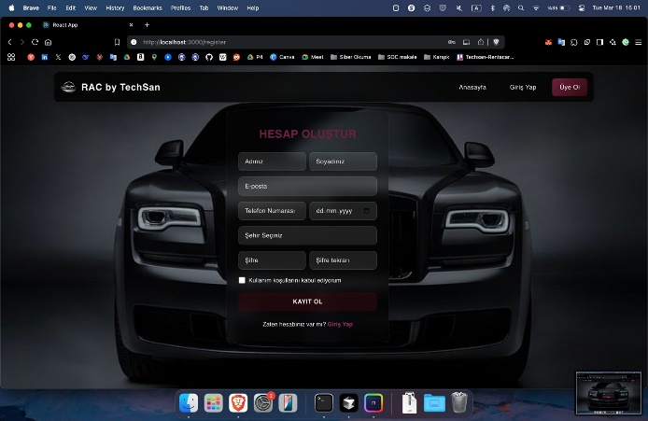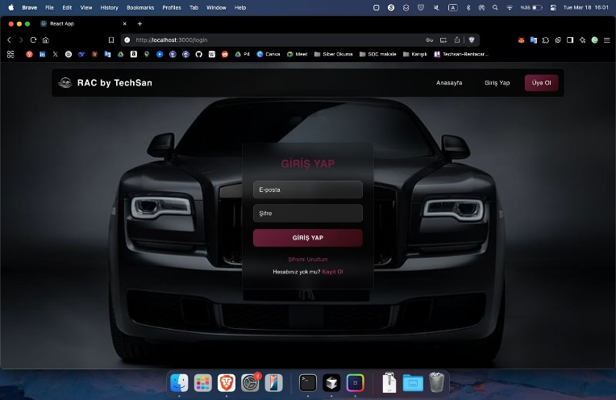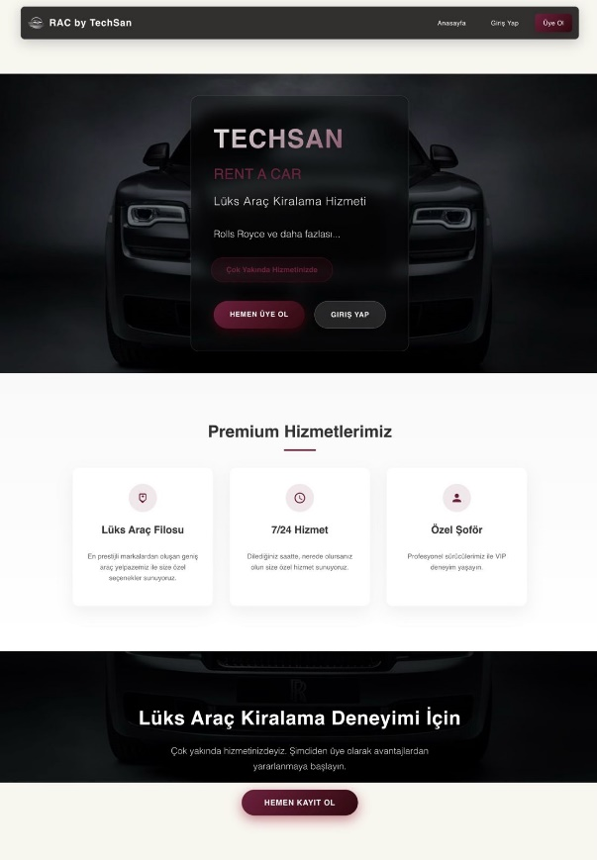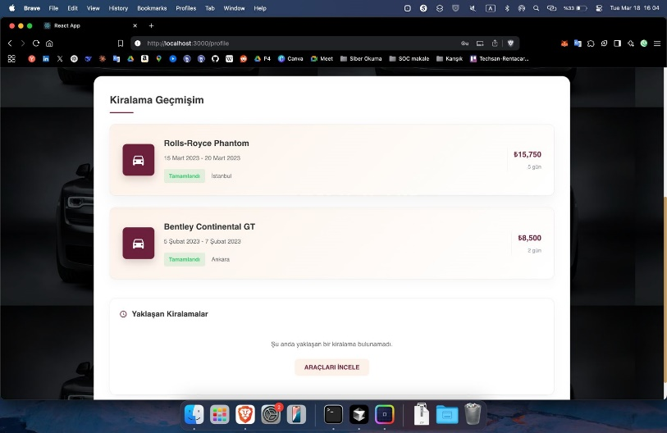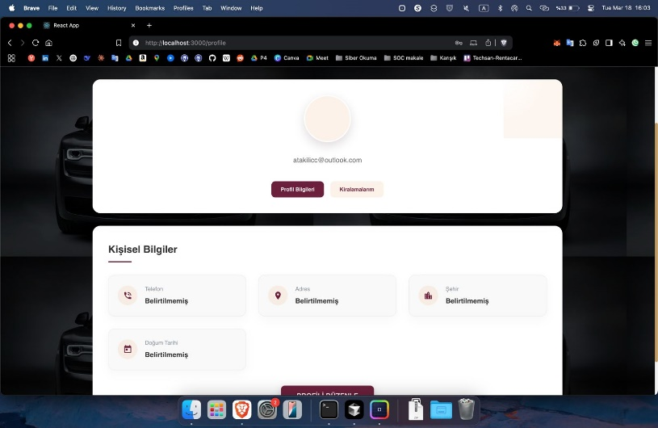

Figure 3: Register Page

Figure 1: Home Page

Figure 2:User Login Page

Figure 5: User Page-2

Figure 4: User Page

## Project Schedule

Sprint 1:

Start Date: 13.03.2025

End Date: 19.03.2025

# Glossary

To establish a clear terminology, developers **identify the participating objects** for each use case. Developers should **identify, name, and describe them** unambiguously and collate them into a glossary.

# References

This subsection should:

* Provide a complete list of all documents referenced elsewhere in the RAD, or in a separate, specified document.
* Identify each document by title, report number - if applicable - date, and publishing organization.
* Specify the sources from which the references can be obtained.

The following is an example of listing a book in this section. Check the text to see how it is cross referenced (The whole document is based on [1]).

1. Bruegge B. & Dutoit A.H.. (2010). *Object-Oriented Software Engineering Using UML, Patterns, and Java*, Prentice Hall, 3rd ed.